Veggies - Sweet Pea Feta Fritters
Yields 16-18 fritters in total.
Tip: Raw patties hold their shape better when cold. For best results, use frozen peas and work quickly.

Ingredients

- 4 cups frozen peas
- 1 bunch spring onions, keep both the white and the green elements, dispose of the ends
- 4 cloves garlic, peeled and whole
- 1 large bunch of mint, keep the leafy bits, dispose of the stalks
- 1 lemon, scrape and save zest; then juice the lemon
- 2 tsp za'atar
- 1 tsp sweet/mild paprika
- 1 tsp spicy paprika
- 1 tsp white pepper
- 1 tsp garlic salt
- 1 cup crumbled feta cheese
- 2 cups gluten-free or paleo flour (or mix/match 1 cup gluten-free, 1 cup paleo…)
- 2 eggs
- ¾ cup vegetable oil (½ cup for the recipe plus ¼ cup for frying)
Optional topping/sauce:
- 1 cup plain yoghurt
- 1 clove garlic
- ½ lemon, scrape and save zest; then juice the lemon

Prepare the batter:
- In the food processor, combine half of the peas and all of the spring onions, garlic, mint, and lemon juice. Process ingredients into a paste. Set aside.
- In a large mixing bowl, combine the remaining peas, lemon zest, all spices, cheese, and flour. Mix well, ensuring that flour and spices coat peas and feta. Break up any large chunks.
- Add to the bowl paste, eggs, and ½ cup of oil. Mix thoroughly.

Prepare the patties:
- Measure ¼ cup of batter and shape into a single patty. Place on a plate and repeat until all of the batter has been used.

Fry:
- In a skillet, warm a bit of oil over a medium-high flame. Once oil is hot, reduce flame to medium-low.
- Arrange a flat layer of patties in the skillet and chill remaining patties in fridge.
- Fry patties 2-3 minutes or until golden brown on each side. Transfer to serving plate and repeat for remaining batter.
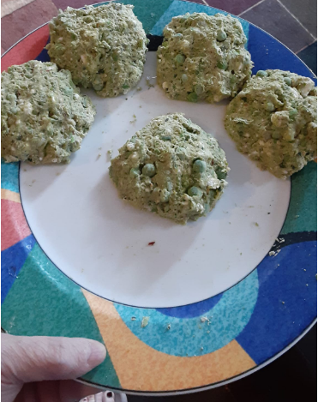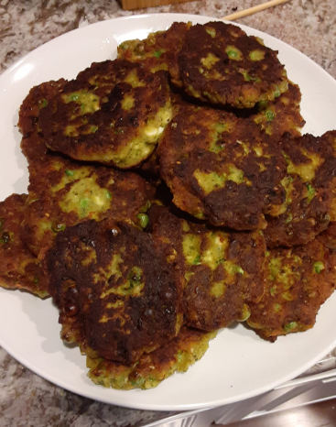

Optional topping:
- In the food processor, combine all ingredients and blend until smooth.

