Tips: Kitchen Hacks

1. | 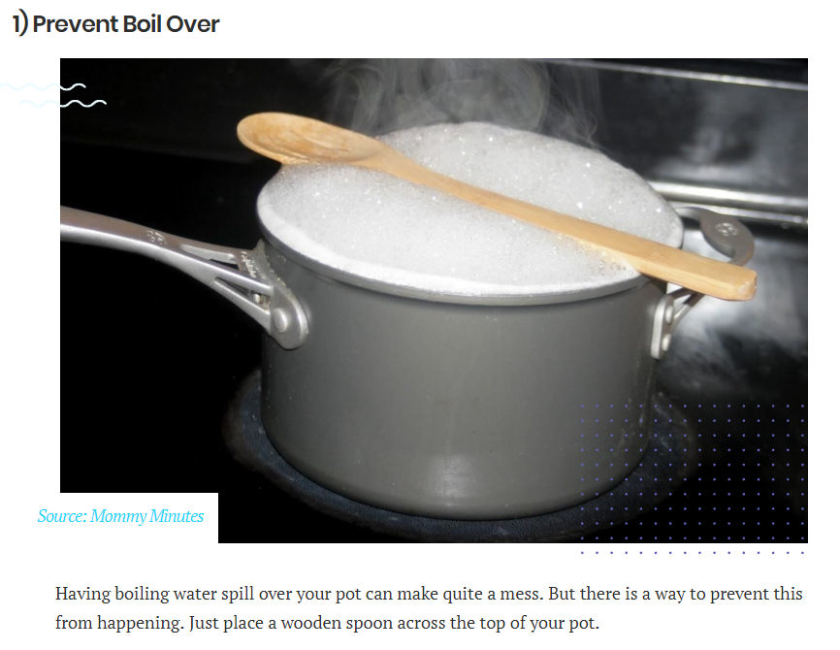 | Prevent Boil Over: Balance a wooden spoon across top of pot.
2. | 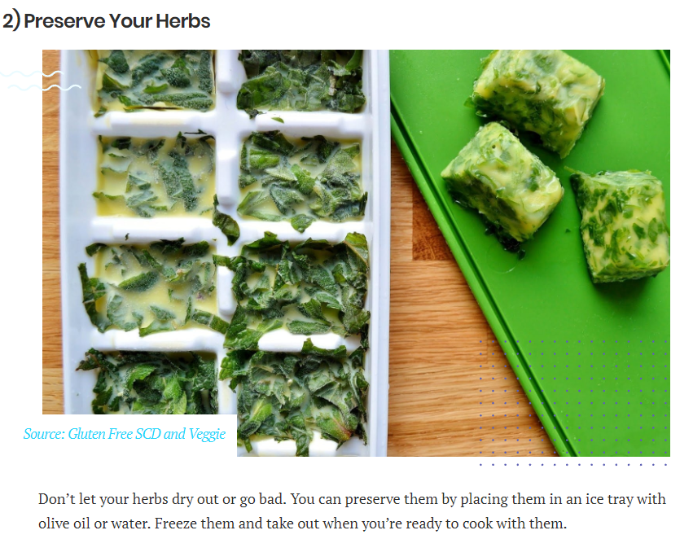 | Preserve Herbs: Place herbs in ice tray with olive oil or water and freeze. Thaw when ready to cook.
3. | 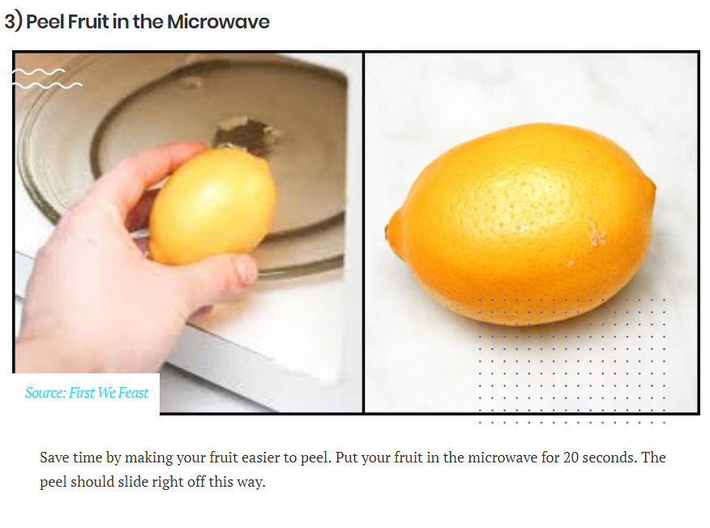 | Peel Fruit: Microwave for 20 seconds. Peel should slide right off.
9. | 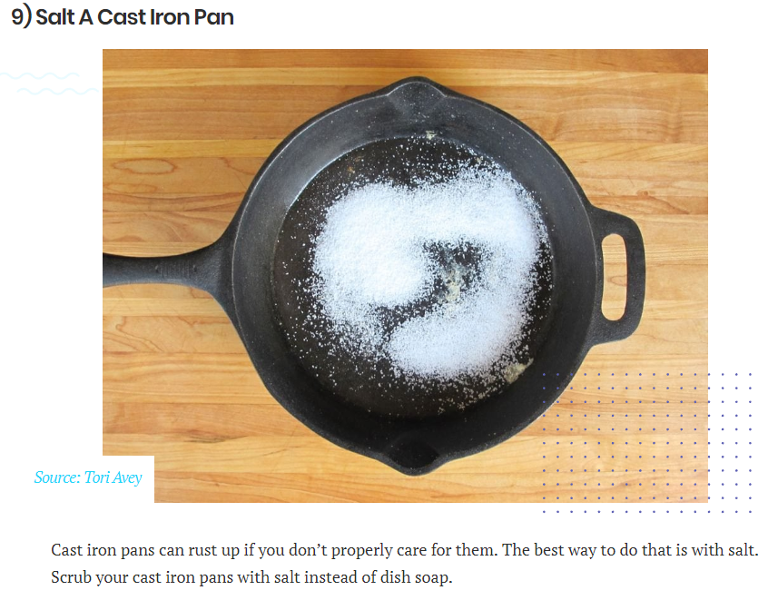 | Clean a Cast Iron Pan: Scrub with salt instead of dish soap to clean your cast iron pans.
14. | 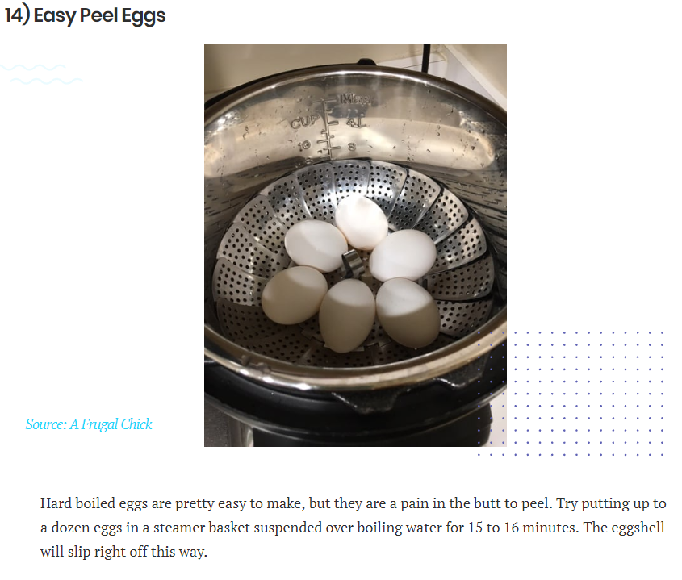 | Easy Peel Eggs: Place a dozen eggs in a steamer basket. Suspend over boiling water 15-16 minutes. Egg shells will slip right off.
19. | 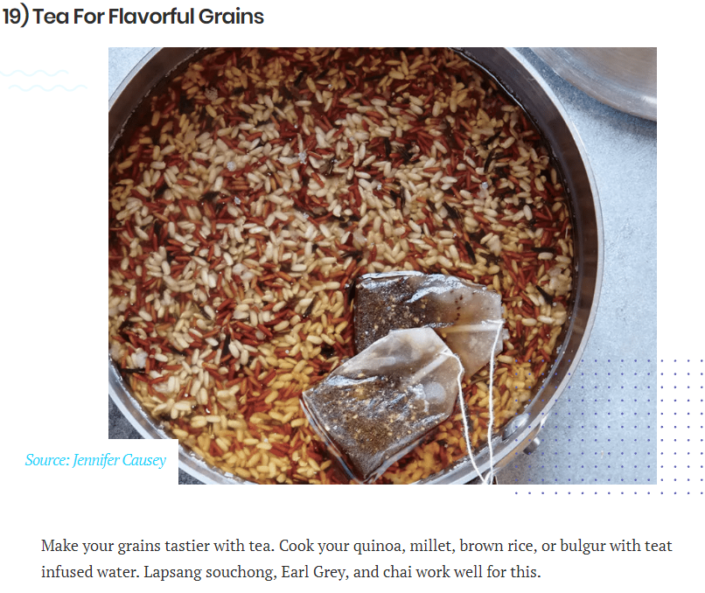 | Add Flavor to Grains: Cook quinoa, millet, brown rice, or bulgar with tea-infused water. Lapsang souchong, Earl Gray and chai work well for this.
23. | 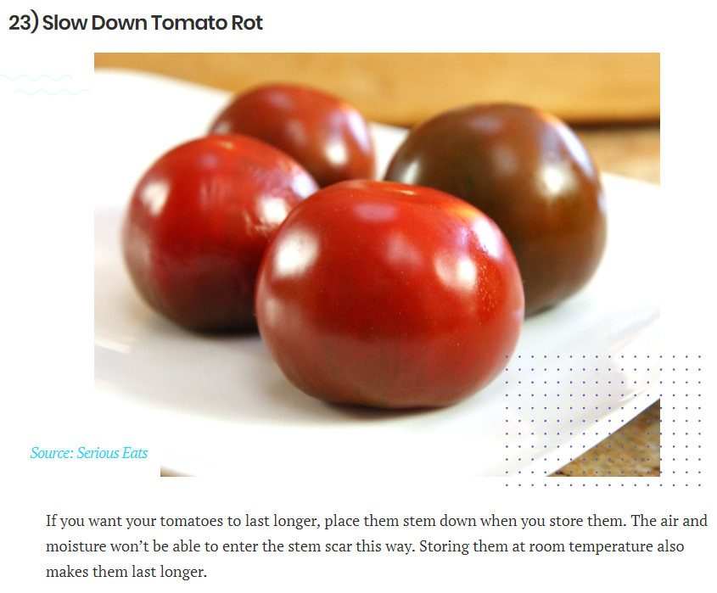 | Slow Down Tomato Rot: (a) Place tomatoes stem down when you store them to prevent air and moisture entering stem scar. (b) Store tomatoes at room temperature.
26. | 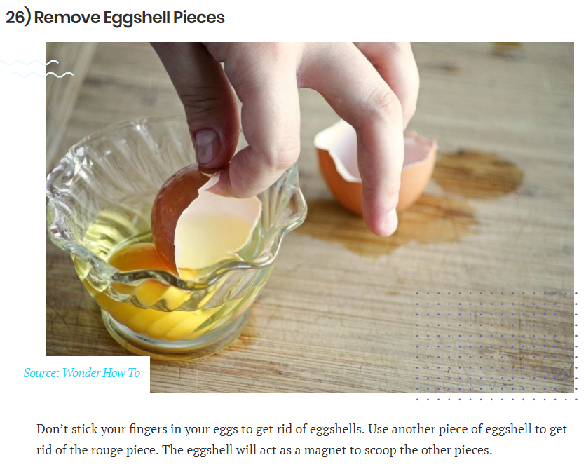 | Remove Egg Shells from Glass: Instead of your fingers or a spoon, use a larger piece of egg shell to attract and scoop the smaller pieces.
32. | 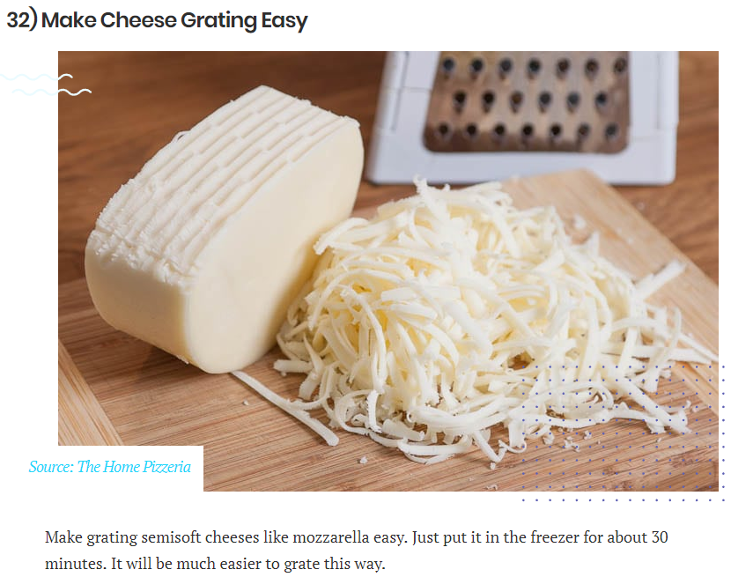 | Grate Cheese: Prior to grating, place semisoft cheeses like mozzarella in freezer for about 30 minutes.
33. | 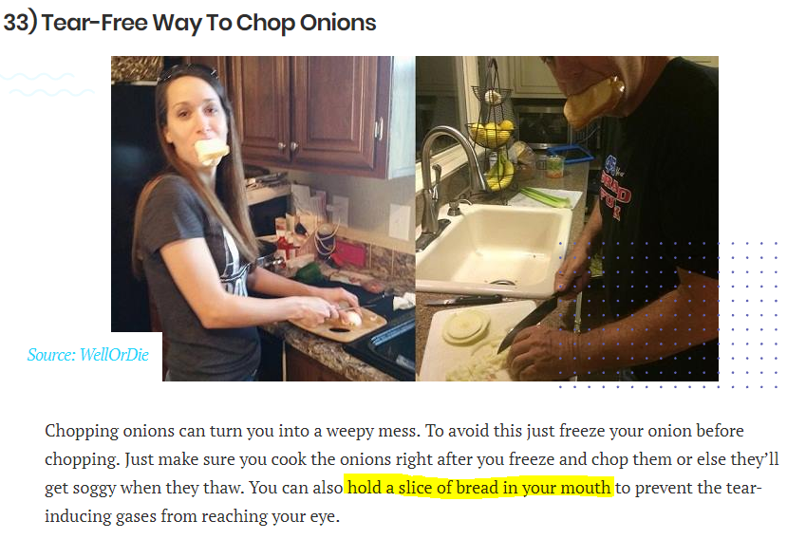 | Chop Onions: (a) Freeze onion just before chopping, but be sure to cook immediately after. (b) Hold a piece of bread in your mouth as you chop. (c) Chop close to stove flame. Anytime you feel teary, stand directly above the flame, which clears your eyes instantly.
36. | 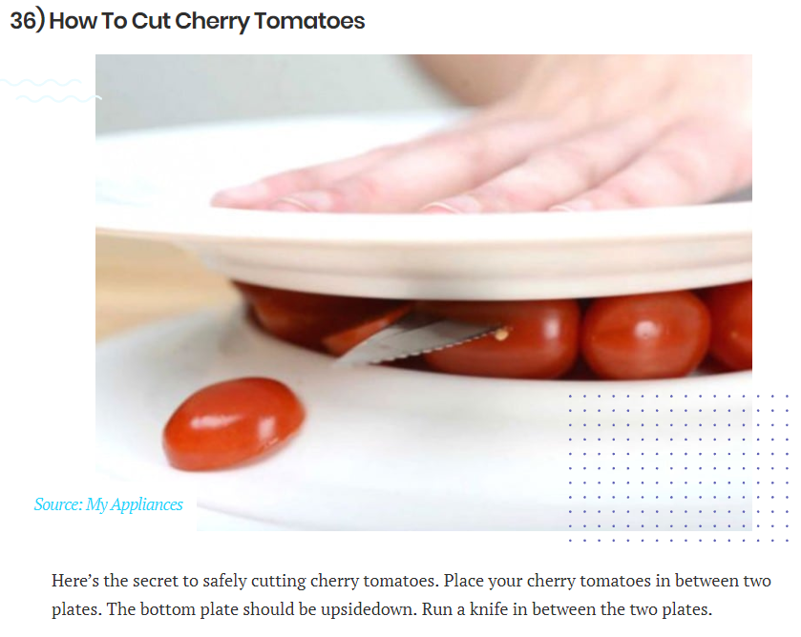 | Cut Cherry Tomatoes: Place a bunch of cherry tomatoes on an upside down plate and cover with another plate (like a sandwich).
