Poached Eggs
- Use Fresh eggs. How do you know how fresh an egg is?
Look at the carton:
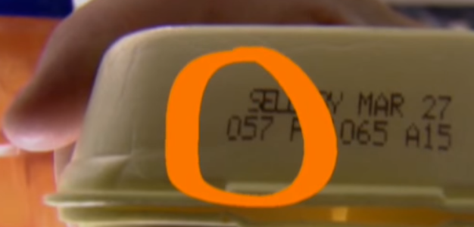
The first 3 numbers represent the # day out of 365 days of the year. In this example, we’re looking at the 57th day of the year, February 26th.
- Bring a non-stick pan or skillet of water filled 5cm deep to a boil.
Alternative: 3”-4” water will yield rounder, shapelier eggs.
- Add a splash of light vinegar.
- Crack eggs into individual small bowls.
Tip: Run eggs (individually) through a fine mesh sieve so as to keep the tight whites, while straining out the loose and liquidy runny whites.
- Lower flame to a simmer (small bubbles).
- Using cutlery, break up bubbles, make them disappear. Then, give a stir and make water swirl.
- While water is still swirling, gently tip individual eggs into the swirling vortex.
- Cover pan. Cook for 2-3 minutes then turn off the heat and leave the pan for 8-10 minutes.
- Lift eggs out with a slotted spoon and drain on paper towel.

