“Toum”
Ingredients:
- 1 cup cloves garlic (4 1/2 ounces; 130g)
- 2 teaspoons kosher salt (for table salt, use 1 teaspoon)
- 1/4 cup (60g) fresh lemon juice (probably 2 lemons). Divide into individual tablespoons
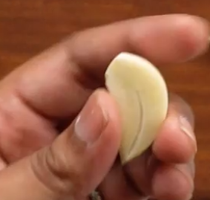
- 1/4 cup (60g) ice water. Divide into individual tablespoons
- 3 cups (600g) neutral oil, such as grapeseed or not canola. Divide into half cups
Global Direx:
- Using a paring knife, split each garlic clove in half lengthwise. With the tip of the knife, remove and dispose of the germ (sprout that runs through the middle of the garlic; it’s more pungent and harsh) from each garlic clove half.
Large Food Processor Direx:
- Place the de-germed garlic and kosher salt in food processor—assuming you have the huge kind that would fit all this. It should also have that huge hole at the top so you can keep it running while you add food. If you don’t have this, scroll down to the mortar/pestle section.
- Pulse in short bursts, occasionally removing the lid to scrape down the sides of the bowl with a flexible rubber spatula, until finely minced.
- Add 1 tablespoon lemon juice and continue processing until a paste begins to form. Add another 1 tablespoon lemon juice and process until completely smooth and slightly fluffy.
- With the food processor running, slowly drizzle in 1/2 cup oil in a very thin stream, followed by 1 tablespoon lemon juice.
- Repeat with another 1/2 cup oil and remaining 1 tablespoon lemon juice.
- Continue the process, alternating 1/2 cup oil and 1 tablespoon water, until you like the flavor.

Mortar and Pestle Direx:
Depending on the size of your mortar, you may need to make the recipe in smaller batches, halving or quartering the ingredient amounts.
- In the mortar, combine garlic and salt and grind until it becomes a smooth paste.
- Work oil into paste, 1 teaspoon at a time, 3 times. Then, follow up with a few drops of lemon juice.
- Repeat until all the oil, lemon juice, and water have been incorporated. Or…Read on:
Finishing up:
- For potent stuff, you will not use all of that oil and water, but it’ll be all used up for a gentler version of toum. It’s done when it looks like marshmallow Fluff.
- Transfer toum to a container and store in the fridge for up to 1 month.

