Crying Tiger Steak
The main dish served with a Thai cucumber salad and/or plain rice is how I prefer my crying tiger. I recommend entirely skipping the traditional dipping sauce (at right) as the steak is so flavorful, I find the extra sauce completely unnecessary.

Ingredients for main dish:  - 1.2 to 1.5 lbs. flank, sirloin, or better steak  - 2 TBSP oyster sauce  - 1½ TBSP fish sauce  - 1 TBSP soy sauce  - 1½ TBSP garlic, minced  - 1 tsp white pepper  - 1½ TBSP sugar  - Salt to taste | Ingredients for nam jim jaew dipping sauce:  - ¼ cup rice  - 2 stalks green onions, chopped  - ¼ cup cilantro, chopped  - ¼ cup shallots, chopped  - 4 TBSP honey  - 3½ TBSP fish sauce  - 2½ TBSP lime juice  - 2 TBSP tamarind concentrate  - 1-3 TBSP Thai chili pepper to taste. Can substitute red pepper flakes or fresh Thai chilis.  - Optional: 1-2 TBSP water to thin out sauce
Direx for steak:
- Place steak in a plastic bag or shallow pan and let sit while you prep remaining ingredients.
- In a medium bowl, combine remaining main dish ingredients and mix until sugar dissolves completely.
- Taste the marinade and adjust as needed, erring on the saltier side as some flavors will dissolve while grilling.
- Dip both sides of steak and saturate in marinade.
Tip: If meat is thick, puncture a few holes in it to allow sauce to seep through.
- Seal bag or cover bowl and refrigerate for 1-5 hours, flipping occasionally.
- Remove from fridge and leave at room temperature for an hour.
- Over a medium-high flame, place steaks on grill or skillet and cook for a couple minutes on each side until desired temperature is reached.
- Allow steaks to rest 5-10 minutes on a cutting board or plate before cutting to allow the juice from the meat to redistribute and keeps the juices locked in within the cooked meat.

Serving suggestion: Cut the meat against the grains into thin strips and serve with dipping sauce.

Direx for dipping sauce:
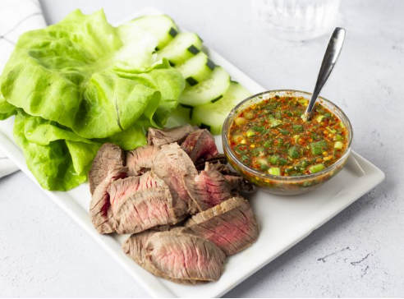
- On medium-low heat, toast uncooked rice in a dry pan (that’s right, no oil!), stirring continually and shaking to prevent sticking, until the rice is golden brown, 10-15 minutes.
Tip: Be careful with the heat level for this step, as the rice tends to cook fast after it browns.
Photo’s source: https://thaicaliente.com/crying-tiger/
- Remove from pan and let cool to room temperature in another vessel that’s not hot (to prevent further cooking). Then grind the rice into a coarse powder. Set aside.
Tip: Leave some in big grains for the extra pop and a crispy taste.
- Combine green onions, cilantro, and shallots in a small bowl.
- Heat honey in a microwave 20-30 seconds, until runny. Let cool. Then pour over veggies and stir well.
- Add fish sauce, lime juice, and peppers. Stir well, tasting and adjusting.
- Add the toasted rice powder. Stir well, tasting and adjusting.

