Baguette Bread (4 loaves)
For a demo, refer to (https://www.youtube.com/watch?v=m08i8oXpFB0&feature=youtu.be)

Ingredients

Dough:
- 700 gr / 25 oz. white bread flour (12% protein or more)
- ½ tsp instant or active dried yeast
- 1 tsp salt or 1 ½ tsp kosher salt
- 520 gr / 19 oz. cold water
- Oil
Tools beyond the Standard:
- Scraper
- Baker’s couche or a well-floured cotton pillow case lining a rectangular cake baking pan
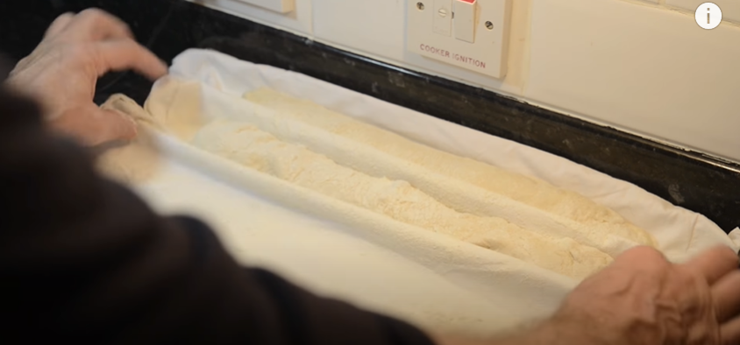
- Aluminum baking pan(s)
- Super sharp knife or razor blade
- Spray bottle with tap water
- Cardboard/tin foil tray: Back of notebook covered in tin foil
Direx
Mix and Let Rise:
- Combine and stir dry dough ingredients.
- Add water. Use the handle of a wooden spoon to mix the ingredients together. Periodically, remove the bits that are stuck to the side of the bowl and recombine into mixture. Keep mixing to homogenize.
- Cover in plastic wrap and set aside 45 minutes. Mixture will NOT be smooth, at this time.
- When 45 minutes are up, remove plastic, wet hands (to make it easier to handle the very sticky dough), fold or turn dough 4-6 times, recover, repeating the 45-minute “wait & fold” process for a total of 4 times.
Work the Dough:
- Place dough on a floured surface after the 4th 45 minutes. Sprinkle flour on top of dough, as well.
- Divide into 4 equal parts. For each, flatten and roll, as though shaping into a crude Swiss roll. Then, stretch and tuck.
- Place on a platter or pan and cover in oiled plastic wrap for 15 minutes.
- Remove a loaf and sprinkle with flour.
- For each, gently smush to flatten to about 1” and again, Swiss roll it. Smush again. Then, roll it a bit, as if to give it the shape of a knockwurst. Tuck ends in.
- Transfer to couche, wrapping ¾ of the loaf by pulling fabric up (see photo). Cover with a towel for 30-32 minutes.
- Place a heat-resistant bowl or pan with boiling or hot water on bottom rack of oven.
- At minute 20, preheat oven to 400˚-430˚. (The final 10-12 minutes of rising happen during the preheat.)
Final Steps:
- Grease an aluminum baking pan large enough to hold all 4 baguettes—or just use 2 pans.
- Use cardboard/tin foil tray to roll baguettes away from couche and transfer to baking pan(s).
- Spray baguettes thoroughly with water.
- Use sharp knife to score baguettes as shown:
- Place baguettes into oven.
- With oven door still open, spray water to cover all oven walls, top, space, etc.
- After 8 minutes of baking, slowly open oven door (beware of steam!) and turn tray 180˚.
- Bake an additional 8 minutes, or until golden brown.
- Cool on a wire rack.

